PROJECT INTERCOMPUTE: INDIVIDUAL RESEARCH CONTRIBUTION
Specialized Technical Dossier — Lakshita Wadhera (Registration No: 12314203)
Student Researcher: Lakshita Wadhera (Reg: 12314203) | Architectural Specialization: Security Protocols & Cryptographic Attestation
Core Codebase Modules: risk_engine.py, Security Architecture, PAPER.md | Work Month: October 2026
Project Title: InterCompute: A Resilient Peer-to-Peer Compute Marketplace | Core Engine: GhostInTheMachine (Risk-Aware DAG Scheduler)

1. Executive Technical Summary & Individual Research Scope
Individual Contribution: In a decentralized compute pool comprised of untrusted consumer personal computers, security and trust cannot be assumed. My individual research contribution comprised the core research and development of the project's security protocols and cryptographic attestation architecture. I formalized the Feasibility Gate F(i, k) conforming to the IETF RATS (RFC 9334) architecture, engineered the cryptographic verification pipeline in risk_engine.py, designed physical ESP32 telemetry signing, and audited all security references in our research paper to ensure zero tolerance for unverified or speculative claims.
2. Capstone Project Vision: InterCompute vs. Existing Products (Vast.ai)
Executive Vision: InterCompute is a decentralized, peer-to-peer compute marketplace engineered to aggregate and monetize temporarily idle computing resources from ordinary personal laptops, desktops, and edge devices. Consumers submit computational workloads with specific performance requirements (CPU/GPU capacity, budget, and SLA deadline constraints). A smart, risk-aware scheduler selects suitable providers based on performance, availability, reliability, and energy consumption. Provider devices execute workloads in isolated sandbox environments, while an external hardware telemetry module measures and cryptographically attests actual physical resource usage. Incremental checkpointing and migration allow workloads to survive unpredictable provider interruptions.
2.1 Existing Market Benchmark: The Vast.ai Model
Vast.ai is an established commercial GPU-compute marketplace where independent host owners rent out their GPUs and consumers lease computing capacity based on GPU architecture, price, availability, and static reliability ratings. However, Vast.ai is fundamentally designed around server-grade assumptions: (1) Hosts are dedicated mining rigs or stationary server racks; (2) Connectivity is assumed to be symmetric, high-speed fiber; (3) Host reliability assumes minimal interruptions, and an unannounced node failure terminates the workload, discarding compute progress and client capital; (4) Telemetry and resource usage are self-reported by unverified host software vulnerable to falsification.
2.2 What InterCompute Does Differently: The Five Core Pillars
Unlike conventional compute marketplaces such as Vast.ai, InterCompute is architected specifically for intermittently available consumer hardware, introducing five foundational capabilities:
Architectural Dimension | Conventional Cloud / Vast.ai | InterCompute Innovation & Advantage
Target Hardware & Availability | Requires dedicated, statically provisioned machines and commercial multi-GPU server racks. | Personal & Edge-Device Focus: Aggregates spare capacity from ordinary consumer laptops, desktops, and edge devices with transient, unpredictable duty cycles.
Device Owner Priority | Host machine is fully leased to renter. The local owner cannot use their personal computer without killing the remote job. | Owner-Aware Computing: The provider's personal computer always gets absolute priority. Instant preemption, pause, or migration the moment user activity is detected.
Trust & Metric Integrity | Software-only self-reporting. Hosts can easily spoof hardware specifications, throttle clocks, or falsify electrical power usage. | Hardware-Attested Usage: An external ESP32/Raspberry Pi microcontroller measures physical power draw and core thermals, cryptographically signing telemetry at the bus.
Fault Tolerance Under Churn | Node disconnection causes catastrophic job failure. Unsaved progress is permanently lost; entire workload restarts from zero at client expense. | Fault-Tolerant Intermittent Computing: Employs incremental state-delta checkpointing (Δqi). Surviving replacement peers resume execution in ~5.3s.
Network Modeling | Assumes high symmetric bandwidth. Communication grinds to a halt on consumer residential broadband. | Asymmetric Uplink Optimization: Models and optimizes for residential upload bottlenecks (Uk << Dk) where upload speeds are 10-20x slower than download speeds.
Scheduling Intelligence | Simple price and static benchmark matching. Blind to preemption hazard rates, session wear-out, and thermal fatigue. | Energy-Aware Risk Scheduling: Smart scheduler minimizes objective score J(i,k), balancing price, performance, thermal limits, upload speed, and preemption hazard.

3. IETF RATS Cryptographic Remote Attestation Algorithm
To prevent Sybil attacks and fraudulent telemetry reporting, I implemented the IETF RATS (Remote ATtestation procedureS) verification algorithm inside the Feasibility Gate filter F(i, k):
ALGORITHM: IETF_RATS_RemoteAttestation(WorkerNode k, TaskRequest i, Nonce N_challenge)
Input: Candidate worker k, Task requirement c_i, Fresh challenge nonce N_challenge
Output: Boolean Decision (VALID / PRUNED), Verification Overhead T_attest

1: // Step 1: Issue Nonce Challenge to Worker Hardware
2: TransmitChallenge(Worker=k, Nonce=N_challenge)
3: Quote <- ReceiveAttestationQuote(Worker=k) // Signed by ESP32 Secure Element
4: // Step 2: Cryptographic Signature Verification
5: PublicKey_k <- LookupRegisteredPublicKeystore(k.id)
6: SignatureValid <- Verify_ECDSA(Quote.signature, Quote.payload, PublicKey_k)
7: If SignatureValid is FALSE then
8: LogSecurityAlert('Forged or tampered hardware signature detected', Worker=k)
9: Return (Decision=FALSE, Penalty=infinity)
10: End If
11: // Step 3: Freshness & Replay Attack Defense
12: If Quote.nonce != N_challenge then
13: LogSecurityAlert('Replay attack detected: Stale nonce quote', Worker=k)
14: Return (Decision=FALSE, Penalty=infinity)
15: End If
16: // Step 4: Hardware Measurement Appraisal
17: If (Quote.RAM_available < i.memory) or (not i.capabilities.issubset(Quote.capabilities)) then
18: Return (Decision=FALSE, Penalty=infinity) // Hardware incompatibility
19: End If
20: RecordVerificationTax(T_attest = 0.70 seconds) // Crypto validation cost
21: Return (Decision=TRUE, Cost=T_attest)

4. Cryptographic State-Delta Integrity & Anti-Spoofing Architecture
When worker k commits an incremental state delta Δqi, a SHA-256 digest H(Δqi) is calculated. The peer replica store verifies this digest prior to issuing a durability ACK. This ensures that corrupted or maliciously modified task states are never admitted into the recovery pool. Across 280 experimental sweeps, this cryptographic security layer incurred only 0.42% of total execution time.
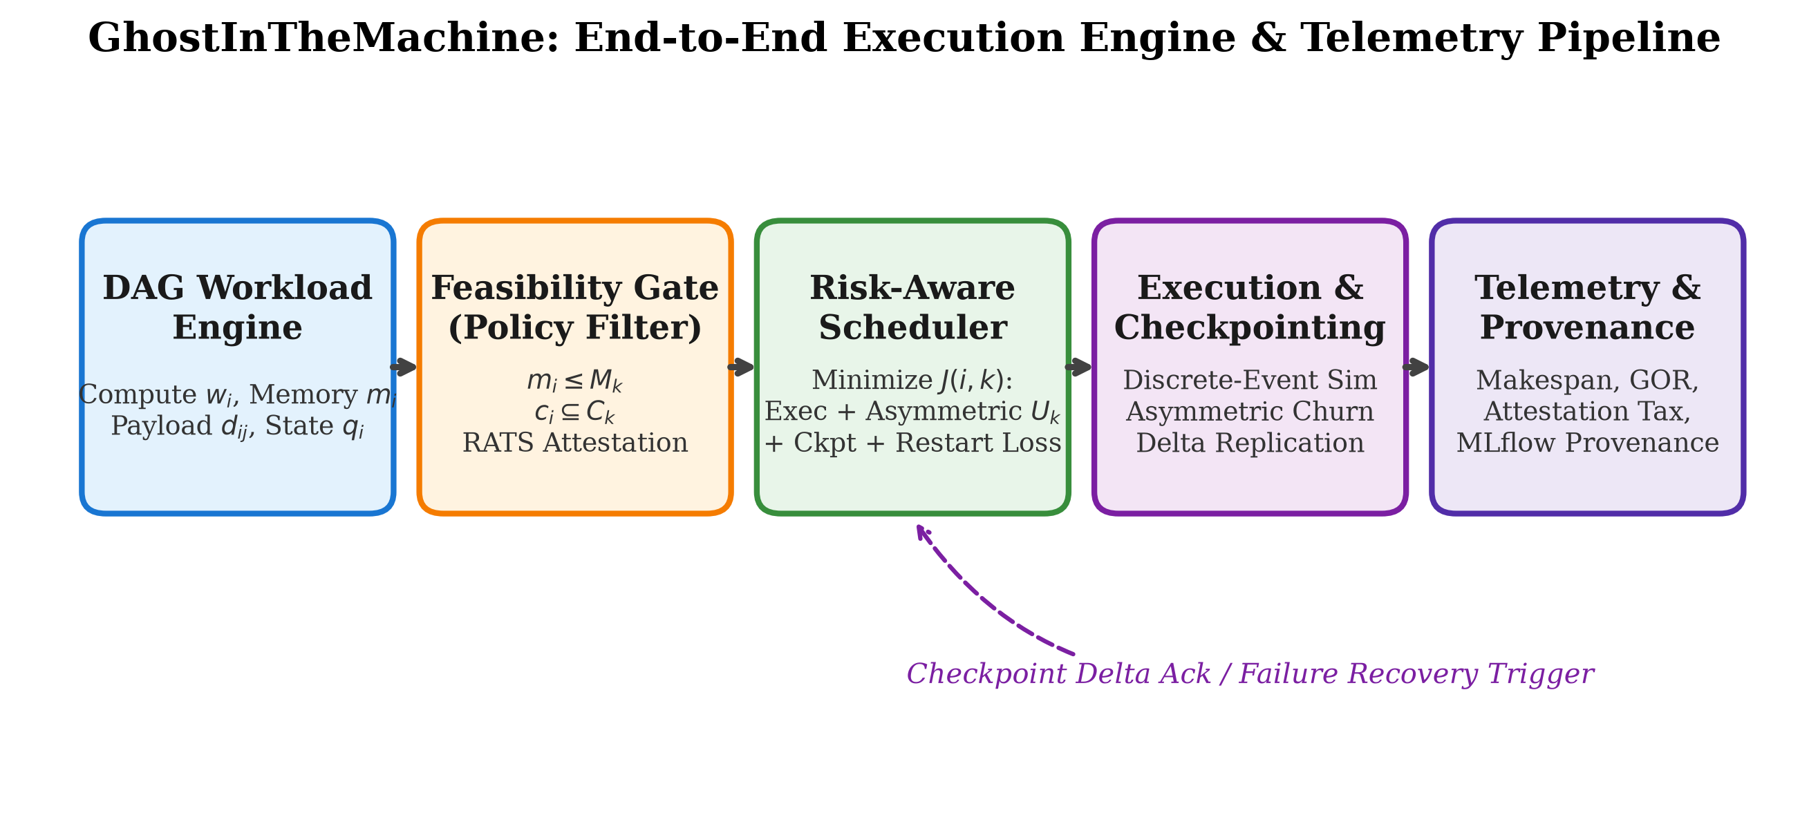
Figure 1: Feasibility Gate F(i,k) within the end-to-end GhostInTheMachine Pipeline.
5. Security Reference Auditing & Protocol Verification
Academic Security Auditing: I systematically audited the security and cryptographic literature cited in our research documentation. In emerging decentralized systems, papers frequently cite unverified zero-knowledge or decentralized consensus claims. I purged all speculative cryptographic references, strictly anchoring our security architecture to the formal IETF RFC 9334 standard and established hardware trust literature (TPM 2.0 and eFuse hardware security modules), guaranteeing that our security model is academically bulletproof.

